**User Manual**

**Geek Goggles**

**To:**  
Mr.Aj Armstrong, Instructor  
Mr. Gary munro, Instructor

**From:**  
Hayden Seivewright, Student

Joshua Akinmoluwa, Student

**Date:**  
April 11, 2025

CMPE2965  
Computer Engineering Technology  
NAIT

**Introduction**

Thank you for choosing Geek Goggles as your heads-up display safety glasses. These glasses will allow you to view uploaded documents, record your projects development and alert you to dangerous environments. The following set of instructions will walk you through basic operation of the Geek Goggles system. Extra details regarding the modes, voice commands and physical layout of your Geek Goggles can be found in the appendices.

**Equipment & Materials**

* Phone or Computer with access to the internet
* Pair of Geek Goggles
* (Optional) Compatible Geek Goggles Peripheral device (currently only Voltmeter is available)

**Instructions**

1. 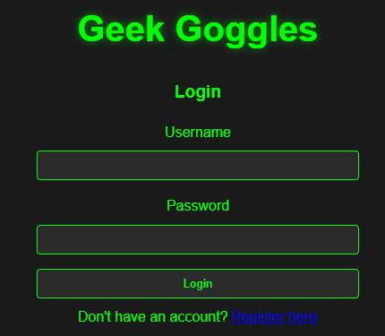Head to the Geek Goggles web app and click create an account, if you already have an account skip to step 3 (Figure 1).

Figure 1 - Login Screen

1. Fill out the sign-up form and create an account, this will redirect you back to the login screen (Figure 2).

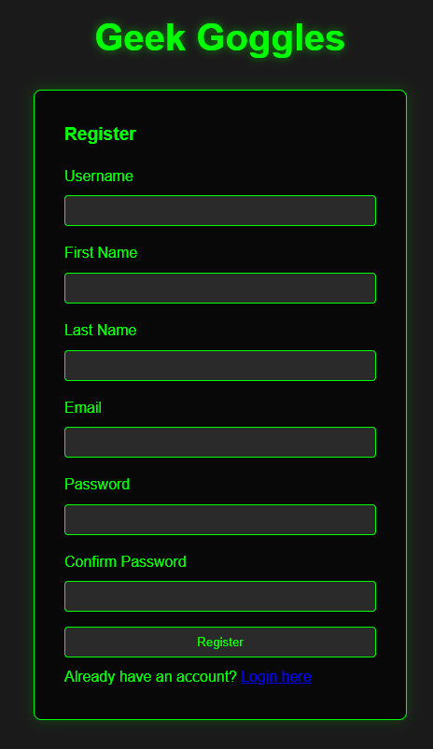

Figure 2 - Login Screen

1. Using your username and password login and you will be brought to the project selection page.
2. 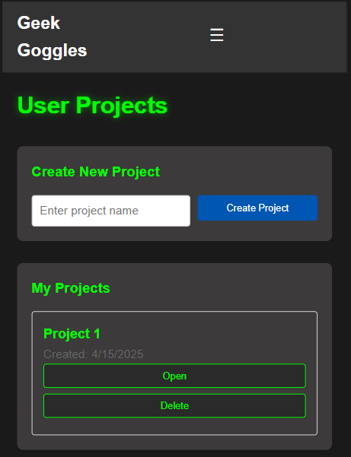On the project selection page if you already have an existing project, you can select “Edit” in the “Project selection” section to be brought to the Project page. If you do not have project, you can create one by entering a name in the “Create New Project” section and clicking “Create project” and then selecting it (Figure 3).

Figure 3 - Projects Screen

1. Turn on your Geek Goggles by plugging in the battery pack.
2. Open your project by clicking the “Open” button on your chosen project under “My Projects”.
3. If you have any documents or pictures you want to view during your project, upload them by dragging and dropping the file into the “Upload documents” section or by clicking in the “drop zone” and selecting your files (Figure 4).
4. Once your files have been selected, click the “Upload” button.
5. If you want to create a note, insert a “Title” and “Note” body in the respective text boxes and click “Save note”
6. A screenshot of a computer

   AI-generated content may be incorrect.Once the files and notes have been uploaded, click the “Sync” button to send them to the Geek Goggles.

Figure 4 - Active Project Screen

1. Carefully put the Geek Goggles on your head. Using the head straps comfortably secure the device.
2. You can now begin your electronics work, please view Modes, Controls and voice commands in the sections below for operational instructions.
3. When you are finished with your current work or project, say “Hello Geek” followed by “Power off” to turn the goggles off. Do not leave the Active project screen until the device powers off. Any voice notes will be transcribed and uploaded to your project file as a text note and any pictures will be uploaded to your project file.
4. View your updates on the web application and write any additional notes.
5. Log out of the Geek Goggles web application.

**Conclusion**

With the steps listed above you have everything you need to successfully login, create a project, upload documents, complete and record your electronics project. Please review the mode types, voice commands, and physical layout on the following appendices for more information on how to get the most out of your Geek Goggles.

# **APPENDICES**

**Appendix A: Geek Goggle Modes**

There are 6 available modes you can cycle through on the Geek googles using the “Mode Button” or Voice Commands (Please view relative sections below for more info). These modes are:

**Time Mode:** Time mode is the most basic and least visually intrusive mode, this mode is recommended for active work on the project. The current time will be displayed on the Heads up display.

**Camera Mode:** Camera mode will display the camera’s current view and allows you to document your project by taking a photo. You can take a photo by clicking the “Action button” or using the “take photo” voice command. Additional commands are listed in the Voice command section.

**Document Mode:** Document mode allows you to view all documents and notes that you have uploaded previously to the web application and can be cycled using the “Action button” or the “Next item” voice command. Additional commands are listed in the Voice command section.

**Sensor Mode:** Sensor mode allows you to view the current temperature and humidity from the Geek Goggles sensors.

**Note Mode:** Note mode allows you to record a 10 second voice note that will be transcribe to text. To start the voice recording use the “Record note” voice command. Additional commands are listed in the Voice command section.

**Tool Mode:** Tool mode allows you to view the incoming data from the attached Geek Goggle peripheral. For example, if you have the Voltmeter peripheral attached you can view the live Volt reading data in this mode.

**Appendix B: Voice Commands**

To use voice commands, the Geek Goggles must be powered on. Before issuing any command, the wake word “Hello Geek” must be clearly spoken followed by a brief pause, then clearly state your command.

**List of commands:**

**Go to next mode:** “next mode”, “next screen”, “next option”, “change mode”, “change screen”, “change option”

**Go to specific mode:** “Go to _____”, “display _____”, “Show _____”

* Followed by mode: “time”, “camera”, “documents”, “sensors”, “notes”, “tool”

**Change displayed documents (must be in documents mode):** “next item”, “next document”, “next image”

**Begin taking a voice note (must be in “notes” mode):** “Record _____”, “Take _____”, “Start _____”

* followed by: “note”, “recording”, “voice note”, “voice recording”

**Take a picture (must be in “camera” mode):** “take ______”, “snap _____”, “capture _____”

* followed by: “photo”, “image”, “picture”, “photograph”

**Power off device:** “shut off”, “shut down”, “power down”, “turn off”, “power off”

**Appendix C: Physical layout**

1. Action Button
2. Mode Button
3. Temperature, Humidity & Air Quality Sensor
4. Microphone
5. Head Strap
6. Combiner Glass
7. Display
8. Camera

